## Instructions

Write a program that interprets the Body Mass Index (BMI) based on a user's weight and height.

It should tell them the interpretation of their BMI based on the BMI value.

* Under 18.5 they are underweight
* Over 18.5 but below 25 they have a normal weight
* Over 25 but below 30 they are slightly overweight
* Over 30 but below 35 they are obese
* Above 35 they are clinically obese.

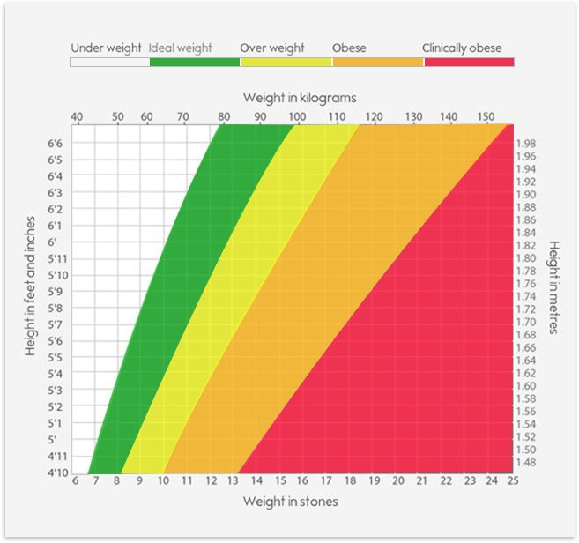

The BMI is calculated by dividing a person's weight (in kg) by the square of their height (in m):

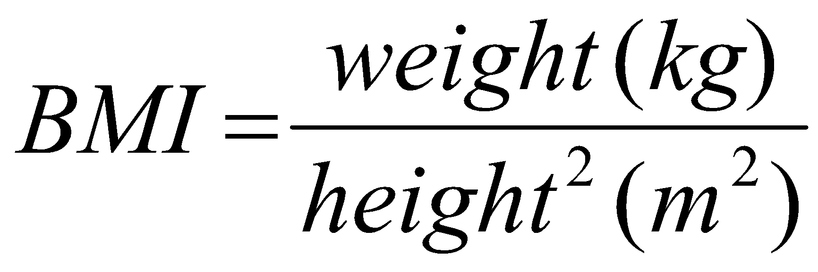**Warning** you should **round** the result to the nearest whole number. The interpretation message needs to include the words in bold from the interpretations above. e.g. **underweight, normal weight, overweight, obese, clinically obese**.

## Example Input

weight = 85

height = 1.75

## Example Output

85 ÷ (1.75 x 1.75) = 27.755102040816325

Your BMI is 28, you are slightly overweight.

e.g. When you hit **run**, this is what should happen:

